# Introduction to HTML/CSS Exercise 5 Abhishek Maurya

1. **How are inline and block elements different from each other?**
   * Inline elements are those elements of HTML which doesn’t start with a new line.
   * They don’t have closing tags since they end in same tags.
   * They are usually used to define a property to the content.

Ex: <a>, <br>, <span>, etc.

* + Block elements are those elements of HTML which always start with a new line.
  + They always have closing tags since they represent to a group of element.
  + They can be used for define the content of a block, or to make a block.

Ex: <head>, <div>, <p>,<ol>,etc

1. **Explain the difference between visibility:hidden and display:none**
   * visibility:hidden means the user will not be able to see the content but it will still take the area.
   * visibility:none means the user will not be able to see as well as it will free space for other content.

Ex: if there is a 2x2 unit picture between two paragraphs then ‘hidden’ will hide but there will be a 2x2 unit space between paragraphs but in case of ‘none’ there will be no space.

1. **Explain the clear and float properties.**
   * float is a CSS property which specifies how an element show flow in a container.
   * clear is also a CSS property which is used with float which specifies that an element won’t be wrapped with the floated element.
2. **Explain difference between absolute, relative,fixed and static.**
   * These all are the methods/attribute of position property used in CSS.
     + absolute is used to relatively position the element to the nearest parent element.
     + relative is used to relatively position an element to its original position.
     + fixed is used to relatively position an element to the viewport.
     + static is used to position an element according to flow of the page.
3. **Write the HTML code to create a table in which there are 4 columns( ID , Employee Name, Designation, Department) and at least 6 rows. Also do some styling to it.**
   * <!DOCTYPE html>  
     <html>  
     <head>  
     <style>  
     table, td, th {   
      border: 1px solid #ddd;  
      text-align: left;  
     }  
     table {  
      border-collapse: collapse;  
      width: 75%;  
     }  
     th, td {  
      padding: 8px;  
     }  
     tr:hover {background-color:#f5f5f5;}  
     </style>  
     </head>  
     <body>  
     <table>  
      <tr>  
      <th>ID</th>  
      <th>Employee Name</th>   
      <th>Designation</th>   
      <th>Department</th>  
      </tr>  
      <tr>  
      <td>3758</td>  
      <td>Akaash</td>  
      <td>Manager</td>  
      <td>IT</td>  
      </tr>  
      <tr>  
      <td>2987</td>  
      <td>Dhruv</td>  
      <td>Manager</td>  
      <td>Finance</td>  
      </tr>  
      <tr>  
      <td>3201</td>  
      <td>Rahul</td>  
      <td>Manager</td>  
      <td>HR</td>  
      </tr>  
      <tr>  
      <td>3687</td>  
      <td>Swati</td>  
      <td>Assistant</td>  
      <td>HR</td>  
      </tr>  
      <tr>  
      <td>3548</td>  
      <td>Vikas</td>  
      <td>Analyst</td>  
      <td>Sales</td>  
      </tr><tr>  
      <td>3789</td>  
      <td>Aditya</td>  
      <td>Designer</td>  
      <td>IT</td>  
      </tr>  
     </table>  
     </body>  
     </html>

**Check answer5 folder**

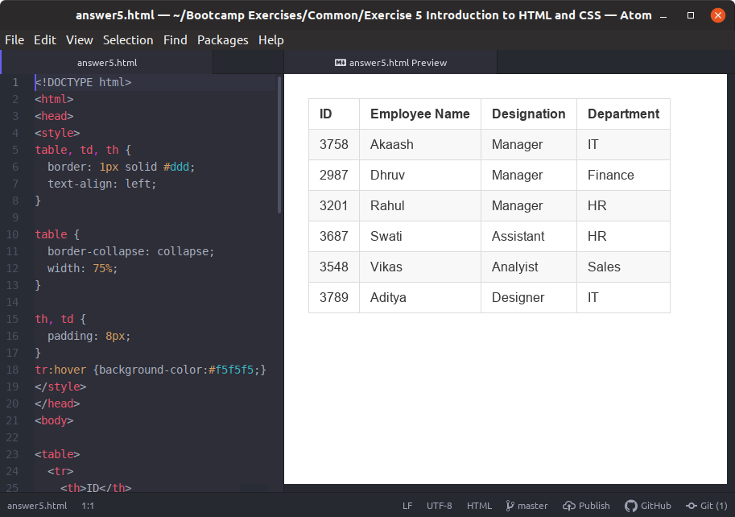

1. **Why do we use meta tags?**
   * Meta means data of data. Since HTML document itself holds some information, meta tags store additional information of the page (which will never be displayed on webpage) like author name, content tags, files on page etc.
2. **Explain box model.** 
   * Elements in HTML can be considered as boxes. In CSS, the ‘box model’ is used when talking about design and layout. Box model describes how the size of each such block and its content is determined through styling instructions.
3. **What are the different types of CSS Selectors?** 
   * CSS selectors are patterns/keywords used to select the element that has to be styled.
4. **Define Doctype.**
   * The <!DOCTYPE> declaration is not a tag, it is an instruction to the web browser about what version of markup language the page is written in.
5. **Explain 5 HTML5 semantic tags.**
   * A semantic element are those elements which describes its meaning to both the browser and the developer.

Ex: <footer>, <time>, <header>, <details>, <summary>, etc.

1. **Create HTML for web-page.jpg (check resources, highest weightage for answers)**
   * <!DOCTYPE html>  
     <html>  
      <head>  
      <title>To The New</title>  
      <link rel="stylesheet" href="layout.css" type="text/css">  
      </head>  
     <body>  
      <div class="wrapper row1">  
      <header id="header">  
      <div id="ttn">  
      <h1>To The New</h1>  
      </div>  
      <tabs>  
      <ul>  
      <li>LINK 1</li>  
      <li>LINK 2</li>  
      <li>LINK 3</li>  
      <li>LINK 4</li>  
      <li>Link 5</li>  
      </ul>  
      </tabs>  
      </header>  
      </div>  
      <div class="wrapper row2">  
      <div id="container">  
      <section><img src="pic2.png"></section>  
      <section id="shout">  
      <p>  
      Hello I am Abhishek Maurya and today I am doing Exercise 5 which is Introduction to HTML/CSS.  
      This question is so time taking but I still managed to do by using a tool which shows me live preview of what I am doing.  
      </p>  
      </section>  
      <div id="homepage">  
      <h1>Latest From The Gallery</h1>  
      <section id="latest" class="last clear">  
      <article class="one_quarter">  
      <figure>  
      <img src="pic1.png">Picture 1  
      </figure>  
      </article>  
      <article class="one_quarter">  
      <figure>  
      <img src="pic1.png">Picture 2  
      </figure>  
      </article>  
      <article class="one_quarter">  
      <figure>  
      <img src="pic1.png">Picture 3  
      </figure>  
      </article>  
      <article class="one_quarter lastbox">  
      <figure>  
      <img src="pic1.png">Picture 4  
      </figure>  
      </article>  
      </section>  
      </div>  
      </div>  
      </div>  
      <div class="wrapper row3">  
      <footer id="footer" class="clear">  
      <p class="left_footer">  
      Copyright 2007-2019 - All Rights Reserved - To The New  
      </p>  
      <p class="right_footer">  
      Template by To The New  
      </p>  
      </footer>  
      </div>  
     </body>  
     </html>

**Check answer11 folder**

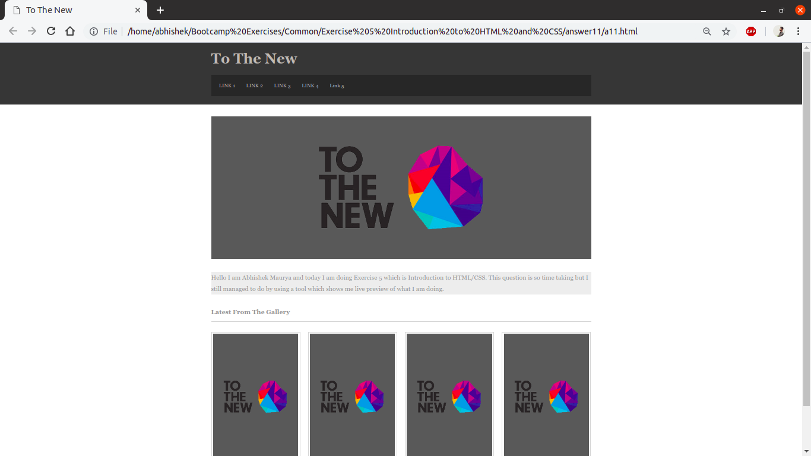

1. **Create HTML for form.png (check resources, highest weightage for answers)**